Thesis Title: Clean Energy Management by ULBs: Case study of New Delhi Municipal Council
Category/ Broad Area: Renewable Energy
Aim
Encourage ULBs to shift to clean energy for environmental and economic benefits while reducing the dependency on other areas for meeting energy requirement.

Objectives
- To review the policy & regulatory framework on solar energy.
- To study good/best practices in India
- To identify the potential areas of intervention & access benefits by using solar photo voltaic panels.
- To suggest/recommend ways to increase/incentivize the mix of solar energy in conventional energy sources.

Scope
- To assess the feasibility of Solar PV Panels in residential, commercial and institutional sector.
- Estimate simple payback period for different sectors
- Calculate Carbon emission reductions

Limitations
- Only electrical energy is being covered under energy and policies & regulatory framework being reviewed is on solar energy only.
- Energy generation study will be limited to building level but methods can be replicated to get estimated for entire city.
- Solar PV systems being considered are grid connected, additional price of batteries will be incurred in case energy needs to be stored.
- Missing information has been suitably assumed

Need for Study
Sustainable development is of utmost importance in urban areas considering their dynamic nature. Studies have shown that urban areas/cities are primarily responsible for climate change attributed to their large resource consumption and nature of activities taking place. For various requirements such as food & electricity they are dependent on other areas without which cities cannot exist. Cities are guzzlers of electricity and with their growth this consumption also increases.
Meeting the energy requirement by means of renewable energy sources is a step towards sustainable development and addressing climate change. Solar energy being a clean energy source and its availability in India and nature of possible decentralized uses makes it widely used source of energy, moreover it can be used by urban local bodies in number of ways to manage the energy requirement in the area under their jurisdiction.
Urban local bodies play vital role in managing basic services like water supply, street lighting, and health services and apart from these various other services for which they pay large amount of money for electricity consumption. While shifting to solar energy ULBs can contribute significantly for their own benefit and at the same time for various other direct and indirect benefits at different levels some of which will be covered in this study.
Since India is a developing nation and second most populous country in the world the energy requirement are bound to increase as the country progresses. This energy (electricity) requirement in the current scenario largely (54.5%) depends on Coal base thermal power pants which contribute to a large amount of pollution cause because of burning of coal. Coal being a non-renewable source of energy is not reliable in long term and also pollution caused by it have adverse health effects.

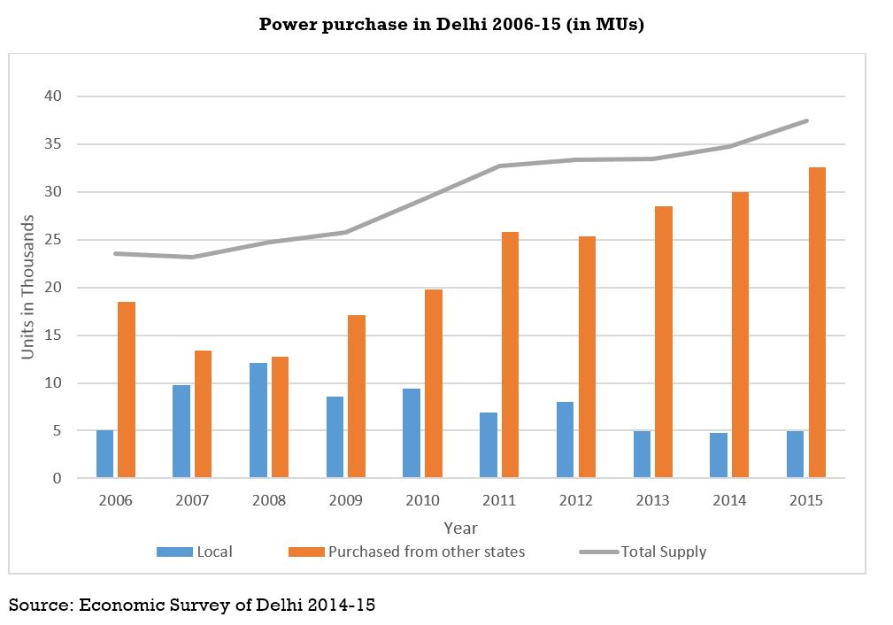
Case Study: New Delhi Area (area under New Delhi Municipal Council)
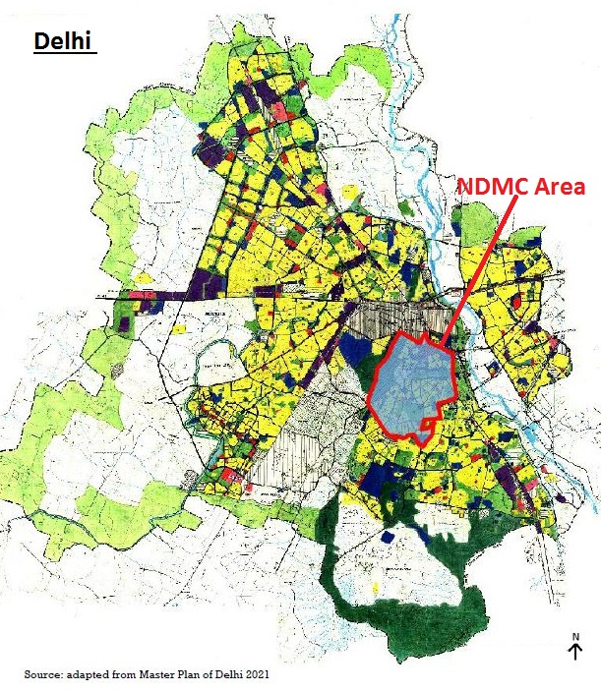

Significance/usefulness of the project
ULBs play a significant role in Clean Energy Management by bridging the gap in various policies by acting as implementation agency, as a large consumer of electricity & as a part of obligatory duty under 74th Constitutional Amendment Act.
- The report shall be useful in estimating the actual payback period for different sectors under ULBs on basis of actual tariff paid.
- It shall enhance the knowledge of reader by providing in-depth view of energy and tariff policies.
- The project shall provide a simple view of complex legislature thus making it easy to understand.
- It provides compiled information, thus reader doesn‘t have to refer many documents.

Abstract: (400 words or more)
This thesis provides an evaluation of the use of clean energy (study covers only solar energy) in urban areas which can be dealt by Urban Local Bodies. Renewable energy becomes important because of the increasing concerns about the climate change and various studies have shown that urban areas/cities are primarily responsible for climate change attributed to their large resource consumption and nature of activities taking place. Cities are guzzlers of electricity and with their growth this consumption also increases. Meeting the energy requirement by means of renewable energy sources is a step towards sustainable development and addressing climate change. Solar energy being a clean energy source and its availability in India and nature of possible decentralized uses makes it widely used source of energy, moreover it can be used by urban local bodies in number of ways to manage the energy requirement in the area under their jurisdiction. Urban local bodies play vital role in managing basic services like water supply, street lighting, and health services and apart from these various other services for which they pay large amount of money for electricity consumption. While shifting to solar energy ULBs can contribute significantly for their own benefit and at the same time for various other direct and indirect benefits at different levels some of which will be covered in this study. Since India is a developing nation and second most populous country in the world the energy requirement are bound to increase as the country progresses. This energy (electricity) requirement in the current scenario largely (54.5%) depends on coal base thermal power pants which contribute to a large amount of pollution cause because of burning of coal. There are numerous issues and problems which hinders the shift from fossil fuels to solar energy, these issues pertains to planning issues, financial viability, coordination, lack of technical expertise and awareness. Municipality can play a significant role for clean energy management by collecting the required data and linking it with its other data which is being used for other services like collection of property tax, expenditure on different services. For effective implementation and proper management GIS map has been proposed which will address the multiple requirements and issues ranging from identification of buildings with large rooftop areas, buildings with high electricity consumption, sectoral classification of buildings, tracking of projects, subsidy provided and benefits obtained, reduction in direct carbon emissions among various other direct and indirect benefits. This will further help in categorization, phasing and understanding the demand and supply and thus calculating the cumulative benefits. This report aims to encourage municipalities to shift to clean energy for environmental and economic benefits while reducing the dependency on other areas for meeting energy requirement.

Main Outcomes/ final analysis/ proposals
NDMC area can provide almost one third of the RPO set for Delhi by 2022. If installation is done on all possible places than approx. 30% of the energy requirement of the NDMC can be met by solar energy alone. This can be further increased by utilizing areas other than roof tops. This can further be increased substantially by using solar panels on street lights, in open spaces, by using cantilever on roof to artificially increase the available rooftop area.
Issues which have been identified can be solved at municipal level with minimal interference of state government. Assistance provided by state government (if any) will encourage municipality to shift to use of solar energy. Some reforms needs to be made at both city and state level for fulfilling the goals set under various missions and programmes.

Keywords: Clean Energy, Solar Energy, Renewable Energy, ULBs, NDMC, New Delhi, Electricity
Guide & Co-guide (optional): – Prof. V.K. Dhar
College/Agency (optional): – School of Planning & Architecture, Delhi
Undergraduate/ Post graduate/ Research work/ Training project/ other (please specify) – Undergraduate (B.Planning)
Author contact info: Shubham Aggarwal (shubham@xyz.com)
Declaration by Author: I have authorized PlanningTank to publish this information and the thesis is a work done by (Your Name) and PlanningTank is not responsible for any information presented.
Declaration by PlanningTank: The information presented is provided by the author with no inputs from PlanningTank. Author has conducted the above stated study and can be contacted for more information. PlanningTank is authorized to contact the author if more information is required about the research work for information author about job opportunities and other purposes.
Note: You can also include any additional information or image which you think is required to provide a better understanding of your work.

